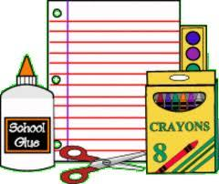
1 box of sharpened # 2 pencils
2 red pens
2 rubber erasers
2 yellow highlighters (other colors are difficult to read)
1 bottle of liquid glue
3 glue sticks
1 package of twistable crayons - 12 pack
1 box of markers
1 pair of children's scissors
2 dry erase markers - black
1 eraser for the dry erase board
3 containers of wipes (for desks)
3 containers of wipes (for hands)
3 large boxes of tissues
1 art smock (an old t-shirt works best)
5 - 2 pocket folders
All sweatshirts, jackets, smocks, and supplies should be labeled with 2B as well as your child's name.

For Art Class:
- A small plastic bin or pencil case to bring to each class with the following materials for drawing time: Sharpened #2 pencils ( not mechanical), white eraser, FIne and Ultrafine Black sharpies, at least 8 thin markers, color pens OR colored pencils ( can be a variety or what you already have)

